SPARQL CODING IN CLASS

PREFIX owl: <http://www.w3.org/2002/07/owl#>

PREFIX rdf: <http://www.w3.org/1999/02/22-rdf-syntax-ns#>

PREFIX xml: <http://www.w3.org/XML/1998/namespace#>

PREFIX xsd: <http://www.w3.org/2001/XMLSchema#>

PREFIX rdfs: <http://www.w3.org/2000/01/rdf-schema#>

PREFIX :<http://www.pizza.com/ontologies/pizza.owl#>

SELECT \*

WHERE {

?SUB ?PRE ?OBJ.

}

LIMIT 10

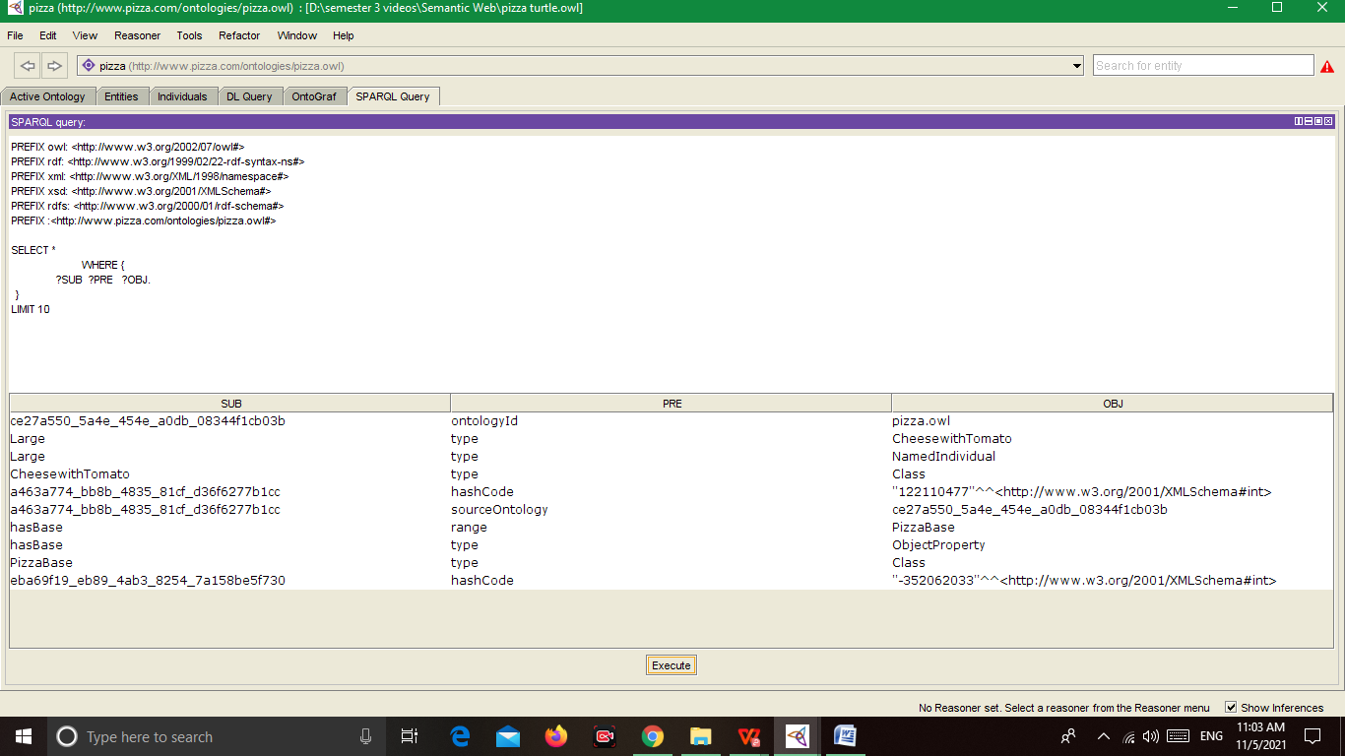

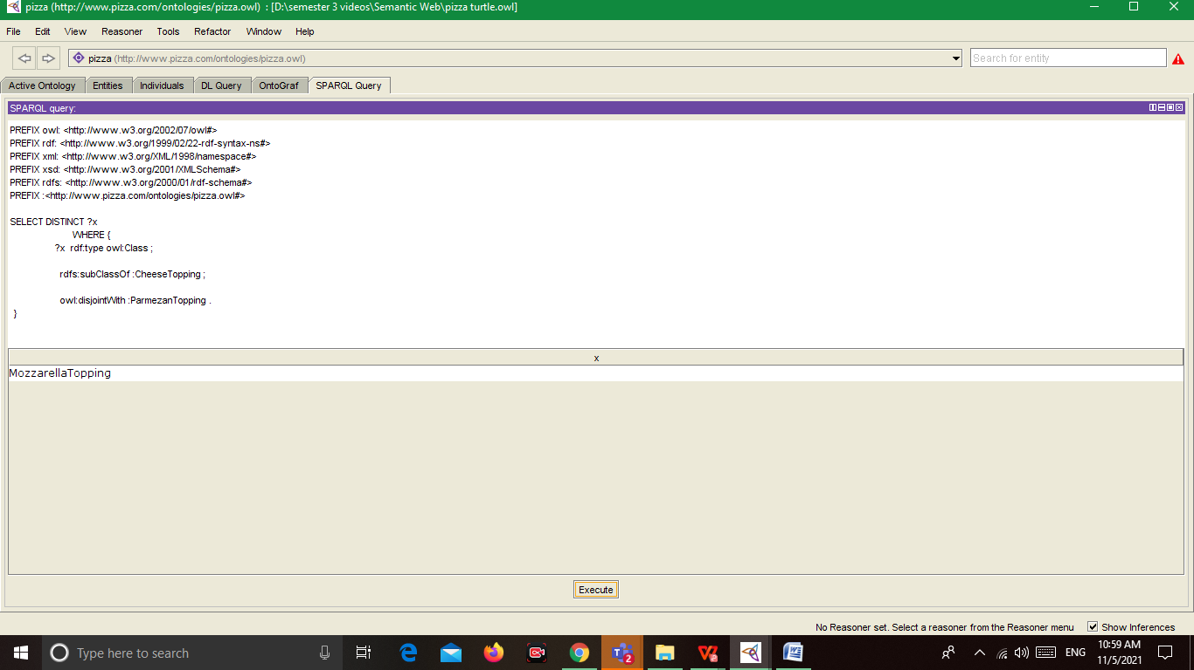

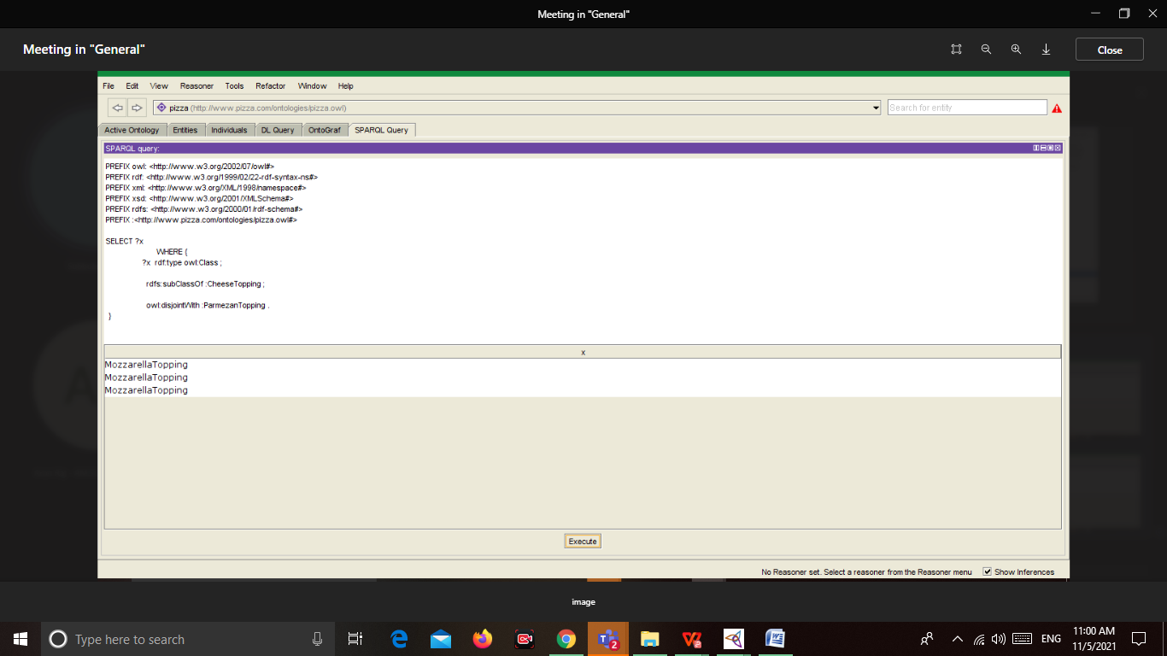

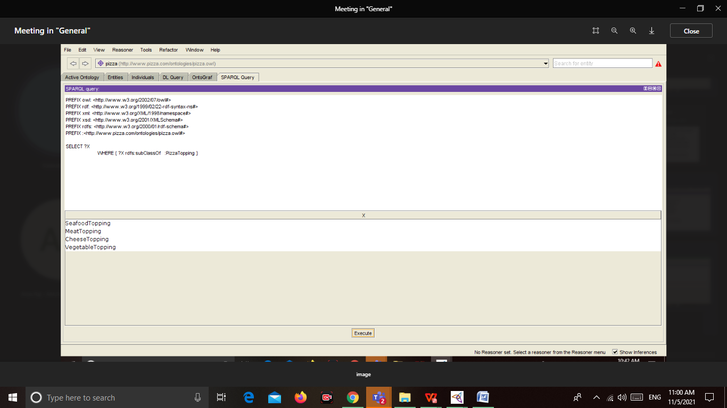

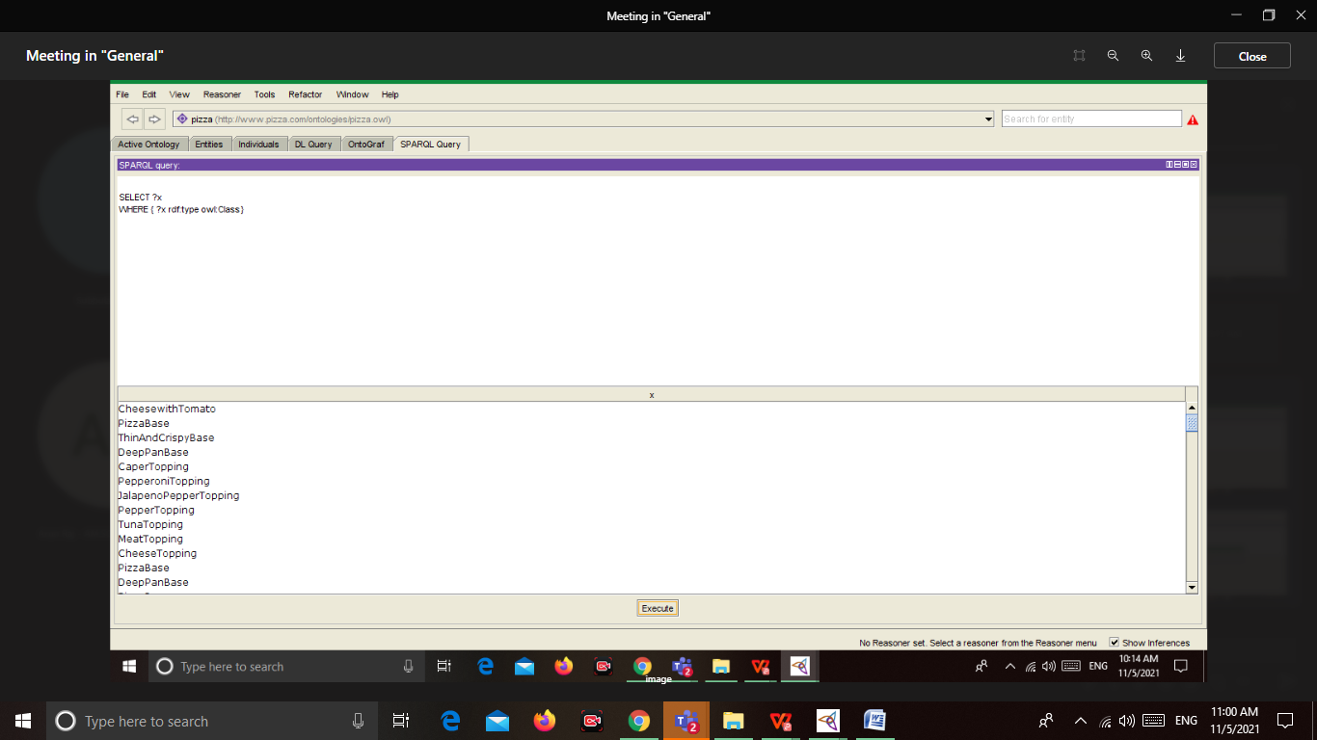

PREFIX owl: <http://www.w3.org/2002/07/owl#>

PREFIX rdf: <http://www.w3.org/1999/02/22-rdf-syntax-ns#>

PREFIX xml: <http://www.w3.org/XML/1998/namespace#>

PREFIX xsd: <http://www.w3.org/2001/XMLSchema#>

PREFIX rdfs: <http://www.w3.org/2000/01/rdf-schema#>

PREFIX :<http://www.pizza.com/ontologies/pizza.owl#>

SELECT DISTINCT ?x

WHERE {

?x rdf:type owl:Class ;

rdfs:subClassOf :CheeseTopping ;

owl:disjointWith :ParmezanTopping .

}

PREFIX owl: <http://www.w3.org/2002/07/owl#>

PREFIX rdf: <http://www.w3.org/1999/02/22-rdf-syntax-ns#>

PREFIX xml: <http://www.w3.org/XML/1998/namespace#>

PREFIX xsd: <http://www.w3.org/2001/XMLSchema#>

PREFIX rdfs: <http://www.w3.org/2000/01/rdf-schema#>

PREFIX :<http://www.pizza.com/ontologies/pizza.owl#>

SELECT (count(?x) as ?count)

WHERE { ?x rdfs:subClassOf :PizzaTopping }

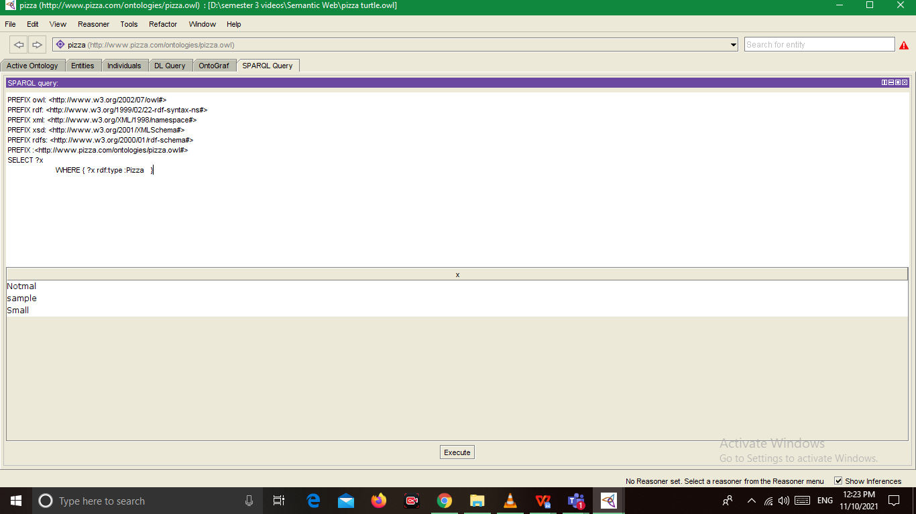

PREFIX owl: <http://www.w3.org/2002/07/owl#>

PREFIX rdf: <http://www.w3.org/1999/02/22-rdf-syntax-ns#>

PREFIX xml: <http://www.w3.org/XML/1998/namespace#>

PREFIX xsd: <http://www.w3.org/2001/XMLSchema#>

PREFIX rdfs: <http://www.w3.org/2000/01/rdf-schema#>

PREFIX :<http://www.pizza.com/ontologies/pizza.owl#>

SELECT ?x

WHERE { ?x rdf:type :Pizza }

PREFIX owl: <http://www.w3.org/2002/07/owl#>

PREFIX rdf: <http://www.w3.org/1999/02/22-rdf-syntax-ns#>

PREFIX xml: <http://www.w3.org/XML/1998/namespace#>

PREFIX xsd: <http://www.w3.org/2001/XMLSchema#>

PREFIX rdfs: <http://www.w3.org/2000/01/rdf-schema#>

PREFIX :<http://www.pizza.com/ontologies/pizza.owl#>

SELECT (count(?x) as ?count)

WHERE { ?x rdf:type :Pizza }

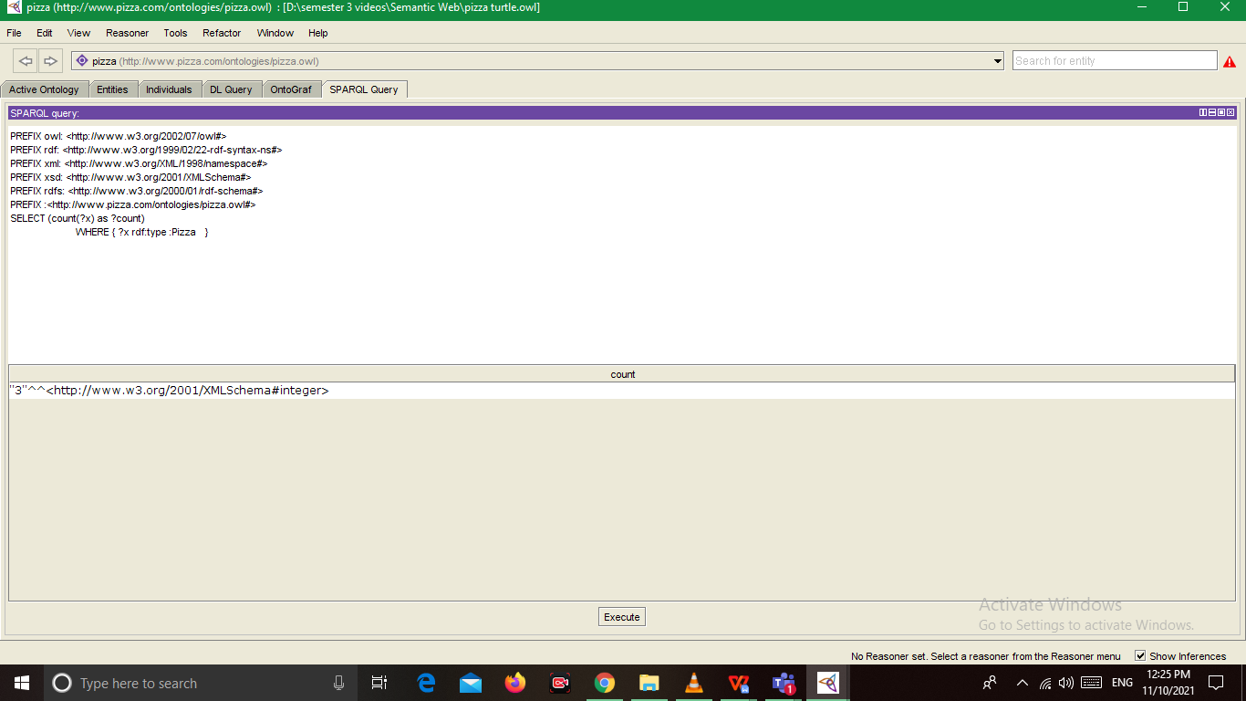

PREFIX owl: <http://www.w3.org/2002/07/owl#>

PREFIX rdf: <http://www.w3.org/1999/02/22-rdf-syntax-ns#>

PREFIX xml: <http://www.w3.org/XML/1998/namespace#>

PREFIX xsd: <http://www.w3.org/2001/XMLSchema#>

PREFIX rdfs: <http://www.w3.org/2000/01/rdf-schema#>

PREFIX :<http://www.pizza.com/ontologies/pizza.owl#>

SELECT (count(distinct ?x) as ?count)

WHERE { ?x rdf:type :Pizza }

PREFIX owl: <http://www.w3.org/2002/07/owl#>

PREFIX rdf: <http://www.w3.org/1999/02/22-rdf-syntax-ns#>

PREFIX xml: <http://www.w3.org/XML/1998/namespace#>

PREFIX xsd: <http://www.w3.org/2001/XMLSchema#>

PREFIX rdfs: <http://www.w3.org/2000/01/rdf-schema#>

PREFIX :<http://www.pizza.com/ontologies/pizza.owl#>

SELECT ?x ?price

WHERE { ?x rdf:type :Pizza ;

:price ?price }

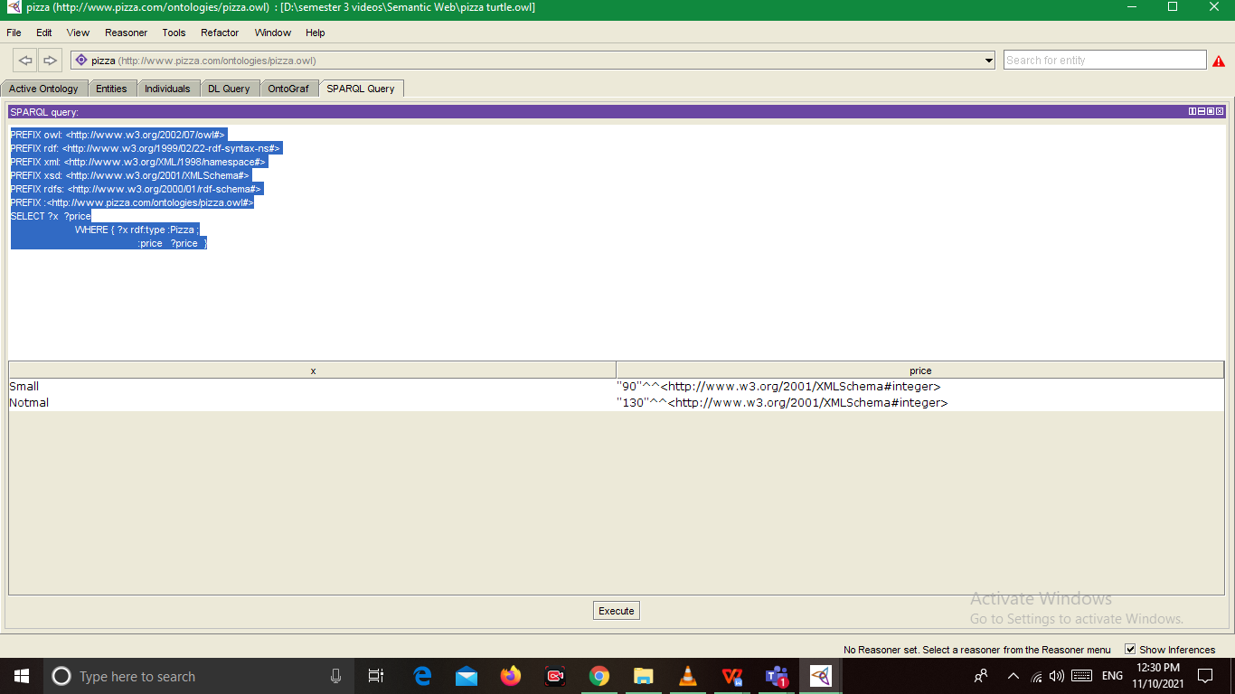

PREFIX owl: <http://www.w3.org/2002/07/owl#>

PREFIX rdf: <http://www.w3.org/1999/02/22-rdf-syntax-ns#>

PREFIX xml: <http://www.w3.org/XML/1998/namespace#>

PREFIX xsd: <http://www.w3.org/2001/XMLSchema#>

PREFIX rdfs: <http://www.w3.org/2000/01/rdf-schema#>

PREFIX :<http://www.pizza.com/ontologies/pizza.owl#>

SELECT ?price

WHERE { :Small rdf:type :Pizza ;

:price ?price }

SELECT ?x

WHERE { ?x rdf:type :Pizza ;

:price ?price

FILTER (?price < 500) }

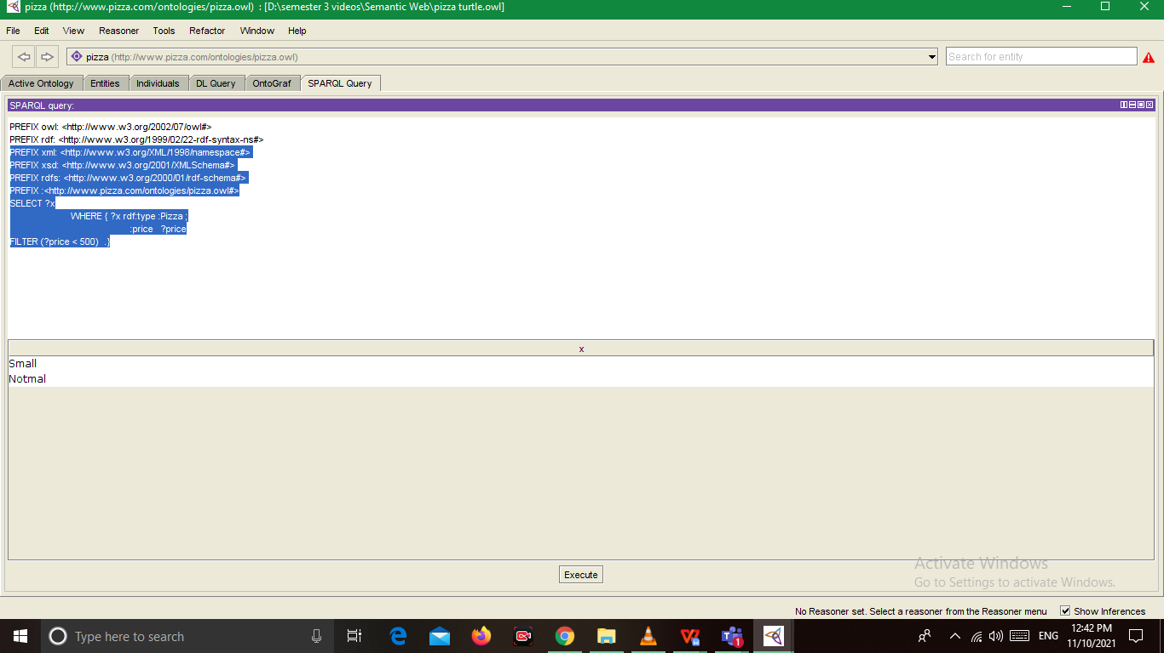

PREFIX owl: <http://www.w3.org/2002/07/owl#>

PREFIX rdf: <http://www.w3.org/1999/02/22-rdf-syntax-ns#>

PREFIX xml: <http://www.w3.org/XML/1998/namespace#>

PREFIX xsd: <http://www.w3.org/2001/XMLSchema#>

PREFIX rdfs: <http://www.w3.org/2000/01/rdf-schema#>

PREFIX :<http://www.pizza.com/ontologies/pizza.owl#>

SELECT ?x ?c

WHERE { ?x rdf:type :Pizza ;

:origin ?c.}

PREFIX owl: <http://www.w3.org/2002/07/owl#>

PREFIX rdf: <http://www.w3.org/1999/02/22-rdf-syntax-ns#>

PREFIX xml: <http://www.w3.org/XML/1998/namespace#>

PREFIX xsd: <http://www.w3.org/2001/XMLSchema#>

PREFIX rdfs: <http://www.w3.org/2000/01/rdf-schema#>

PREFIX :<http://www.pizza.com/ontologies/pizza.owl#>

SELECT ?x ?c

WHERE { ?x rdf:type :Pizza ;

:origin ?c

FILTER(?c = "Indian") .

}

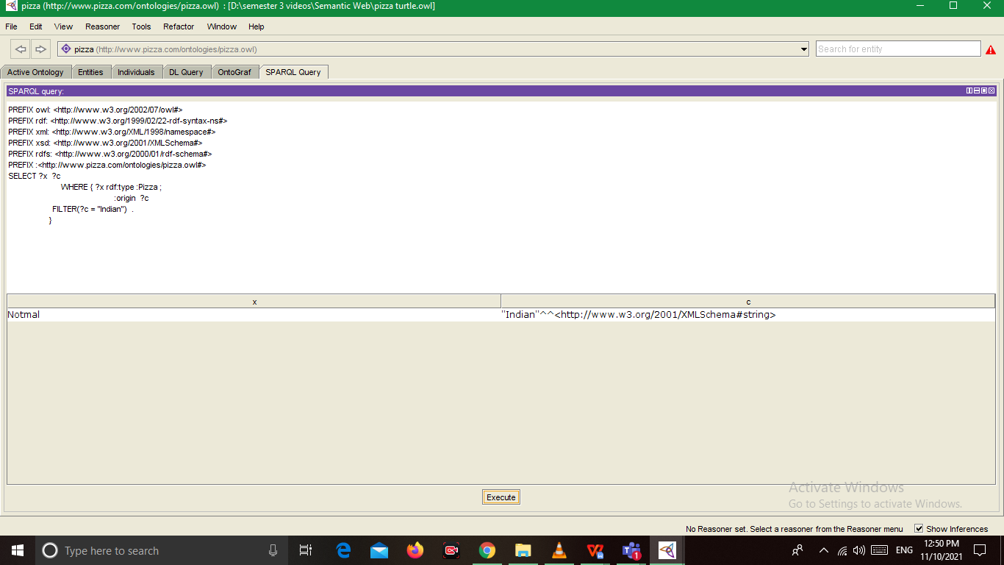

PREFIX owl: <http://www.w3.org/2002/07/owl#>

PREFIX rdf: <http://www.w3.org/1999/02/22-rdf-syntax-ns#>

PREFIX xml: <http://www.w3.org/XML/1998/namespace#>

PREFIX xsd: <http://www.w3.org/2001/XMLSchema#>

PREFIX rdfs: <http://www.w3.org/2000/01/rdf-schema#>

PREFIX :<http://www.pizza.com/ontologies/pizza.owl#>

SELECT ?x ?p

WHERE { ?x rdf:type :Pizza ;

OPTIONAL {?x :price ?p}

}

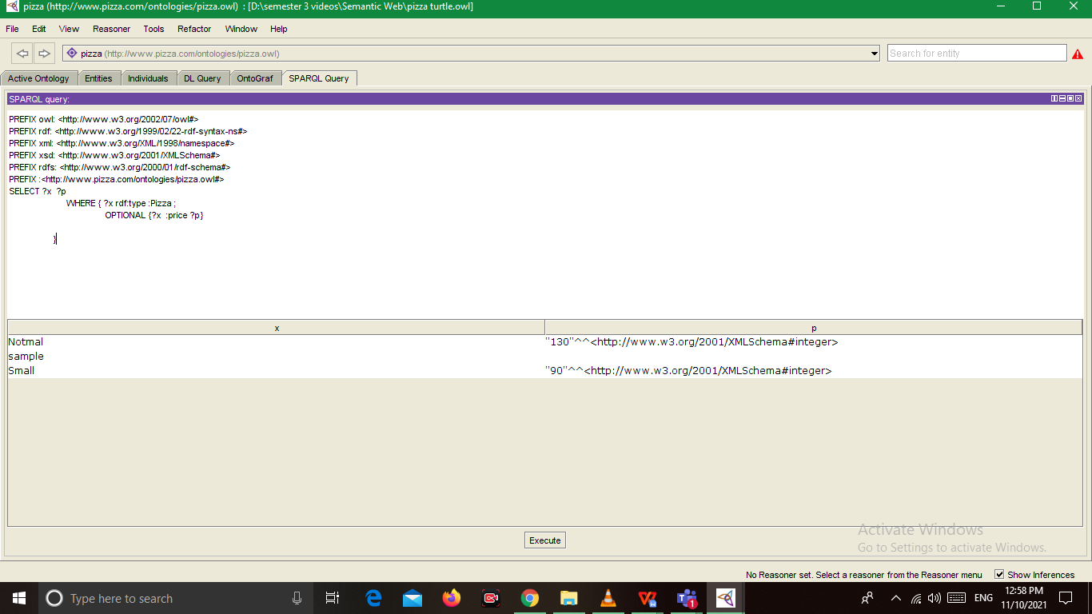

PREFIX owl: <http://www.w3.org/2002/07/owl#>

PREFIX rdf: <http://www.w3.org/1999/02/22-rdf-syntax-ns#>

PREFIX xml: <http://www.w3.org/XML/1998/namespace#>

PREFIX xsd: <http://www.w3.org/2001/XMLSchema#>

PREFIX rdfs: <http://www.w3.org/2000/01/rdf-schema#>

PREFIX :<http://www.pizza.com/ontologies/pizza.owl#>

SELECT ?x ?p

WHERE { ?x rdf:type :Pizza .

OPTIONAL {?x :price ?p}

}